Balanced tree is still the best! Best Average Comparisons: 𝒍𝒐𝒈 𝒏! = 𝜴(𝒏 𝒍𝒐𝒈 𝒏)

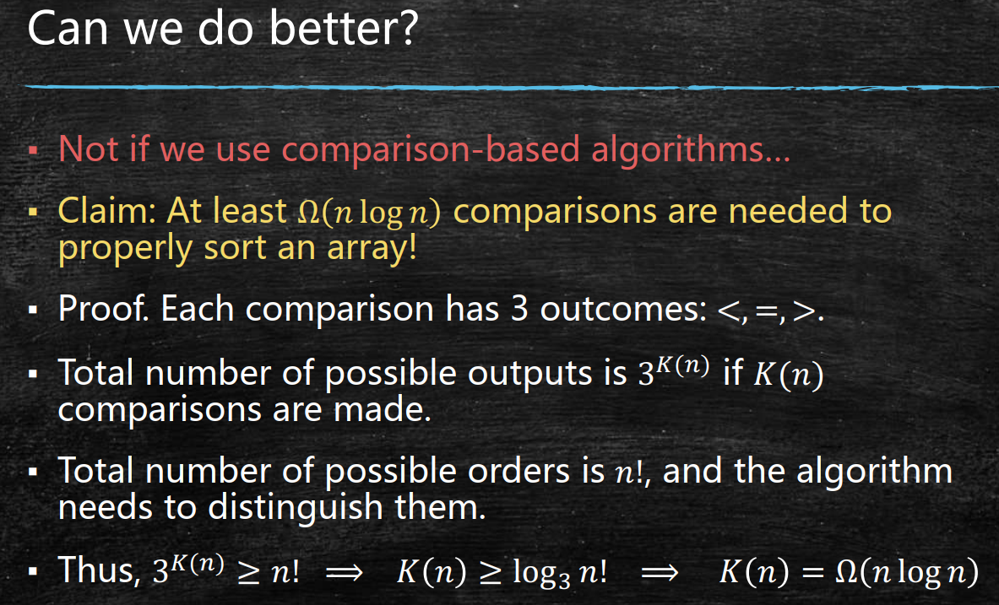

Remember not to use inductionwith Big O notations!

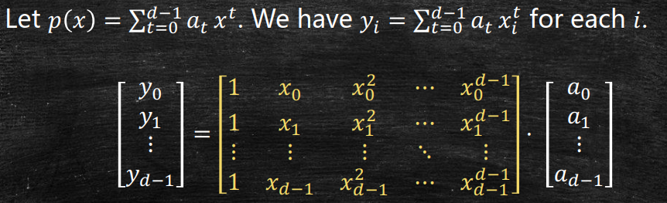

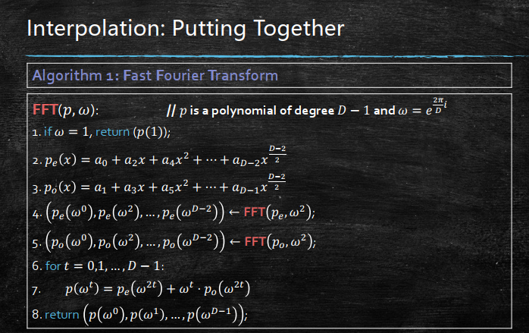

Earliest Finish Time is a tail in dfs

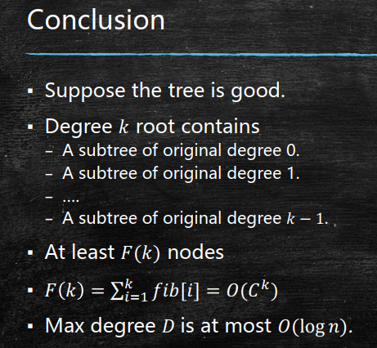

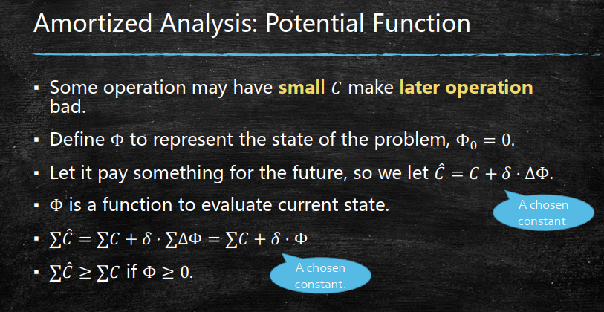

从一个已有的符合要求的东西去扩展如最小生成树

